**(Static by commands)**

**Experiment No:** 05

**Title:** Configure multiple network of each two router.

**Problem Statement:**

To learns how to configure multiple router for packet transmission configuration by commands in Cisco packet tracer simulation software.

**Objective:**

Multiple devices are connected with switches and the switches are connected with different routers. The routers are connected with each other. We will build a network between the devices via switches and devices so that we can send massages or data using that network.

**Hypothesis:**

At first we made a proper connection by setting up IP address of each PC and provide a Next hope IP address for packet transmission between two or more LAN.

**Materials:**

Cisco Packet Tracer Software

**Devices:**

1. 2 Router
2. 3 Switches
3. 6 PC
4. Copper straight cable
5. Copper Cross-Over cable
6. Serial DCE

**Topology:**

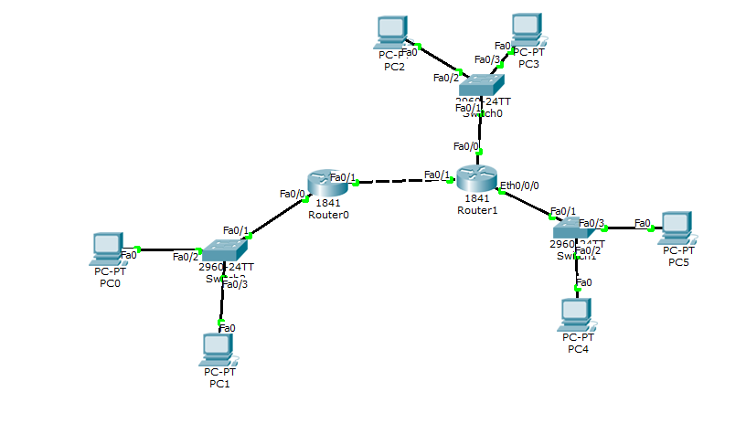

**Configuration:**

**PC0: PC1:**

IP: 192.168.1.1 IP: 192.168.1.2

Subnet mask: 255.255.255.0 Subnet mask: 255.255.255.0

Gateway: 192.168.1.254 Gateway: 192.168.1.254

**PC2: PC3:**

IP: 192.168.2.2 IP: 192.168.2.1

Subnet mask: 255.255.255.0 Subnet mask: 255.255.255.0

Gateway: 192.168.2.254 Gateway: 192.168.2.254

**PC4: PC5:**

IP: 192.168.3.1 IP: 192.168.3.2

Subnet mask: 255.255.255.0 Subnet mask: 255.255.255.0

Gateway: 192.168.3.254 Gateway: 192.168.3.254

**Routing command:**

**Router 0:**

///Adding ip address to the interface

Router>en

Router#conf t

Router(config)#interface f0/0

Router(config-if)#ip add 192.168.1.254 255.255.255.0

Router(config-if)#no shut

Router(config-if)#exit

Router(config)#interface f0/1

Router(config-if)#ip add 192.168.4.1 255.255.255.0

Router(config-if)#no shut

Router(config-if)#exit

**///** static routing commands

Router(config)#

Router(config)# ip route 192.168.2.0 255.255.255.0 192.168.4.2

Router(config)# ip route 192.168.3.0 255.255.255.0 192.168.4.2

**Router 1:**

///Adding ip address to the interface

Router>en

Router#conf t

Router(config)#interface f0/0

Router(config-if)#ip add 192.168.4.2 255.255.255.0

Router(config-if)#no shut

Router(config-if)#exit

Router(config)#interface f0/1

Router(config-if)#ip add 192.168.2.254 255.255.255.0

Router(config-if)#no shut

Router(config-if)#exit

Router(config)#interface eth0/0/0

Router(config-if)#ip add 192.168.3.254 255.255.255.0

Router(config-if)#no shut

Router(config-if)#exit

**///** static routing commands

Router(config)#

Router(config)# ip route 192.168.1.0 255.255.255.0 192.168.4.1